Havo/VWO B1E Onderwerp: optellen en aftrekken van breuken

1  $$\frac{5}{6}+-\frac{1}{4}=$$ | 2  $$-2\frac{1}{3}--1\frac{3}{4}=$$ | 3  $$1\frac{2}{5}+\frac{7}{9}=$$ | 4  $$7-1\frac{5}{7}=$$ | 5  $$1\frac{4}{5}+\frac{1}{3}=$$ | 6  $$1\frac{5}{6}-\frac{3}{4}+\frac{5}{10}=$$
7  $$\frac{5}{8}-\frac{3}{24}=$$ | 8  $$5\frac{1}{3}--1\frac{1}{5}=$$ | 9  $$\frac{4}{15}+-\frac{1}{4}+\frac{3}{10}$$ | 10  $$6\frac{1}{2}-\frac{1}{4}+\frac{10}{10}$$ | 11  $$-\frac{7}{9}--1\frac{14}{18}$$ | 12  $$\frac{9}{6}+-1\frac{1}{2}=$$
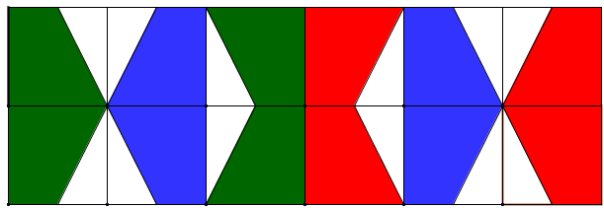

1  $$5\frac{2}{7}$$ | 2  $$-\frac{7}{12}$$ | 3  $$7\frac{1}{4}$$ | 4  $$2\frac{2}{15}$$ | 5  $$1\frac{7}{12}$$ | 6  $$\frac{5}{12}$$
7  $$\frac{5}{12}$$ | 8  $$4\frac{2}{15}=$$ | 9  $$\frac{7}{12}$$ | 10  $$2\frac{8}{45}$$ | 11  0 | 12  $$\frac{7}{9}$$

